**Coding Challenge-2**

**Question:**

**Leverage the practises of CI and CD Using azure Data engineering and explain the architecture of the Azure synapse.**

**Solution:**

**CI and CD**

Continuous Integration and Continuous Deployment (CI/CD) practices are essential in Azure Data Engineering, ensuring automated and streamlined processes for development, testing, and deployment.

**Continuous Integration(CI):**

Every time a new change is made like a piece of code is added to the existing one it is tested first for any errors or anomalies that might affect the whole structure. This ensures that your new addition didn't introduce any problems. If there's an issue, you know instantly and can fix it before it becomes a bigger problem.CI checks and tests every new piece of code (or data transformation logic) you add to your data pipeline.

Continuous Integration (CI) in data pipelines:

**Automated Testing:** Automated tests check the integrity and quality of data transformations, ensuring that data is processed as expected and any error is spotted early.

**Version Control:** Data pipeline code (e.g., SQL scripts, Python transformations) is stored in repositories like Git, allowing tracking and managing changes.

**Consistent Environment:** CI tools can run tests in environments that mirror production, ensuring that differences in configuration or dependencies don't introduce errors.

**Data Quality Checks:** These might include checks for null values, data range violations, data type mismatches, or other custom quality rules.

**Continuous Deployment(CD):**

Once you've confirmed that your new addition fits the existing structure and the process runs smoothly, you immediately use the updated structure. In other words, as soon as the changes are verified, they're made live and functional in the main production environment.CD ensures that once tested and approved, this code gets added to the live system without manual intervention.

Continuous data pipeline deployment:

**Automated Deployment**: Once code changes pass all CI checks, CD tools can automate their deployment to production, ensuring seamless data flow.

**Monitoring and Alerts**: Once deployed, monitoring tools keep track of the data pipeline's performance, data quality, and any potential issues. Automated alerts can notify on discrepancies.

**Rollbacks:** In case an issue is identified post-deployment, CD processes allow for quick rollbacks to a previously stable state of the data pipeline.

**Infrastructure as Code (IaC):** Many CD tools support IaCs. For example, cloud resources such as storage or compute can be provisioned automatically as part of the deployment process.

**Azure Synapse Architecture**:

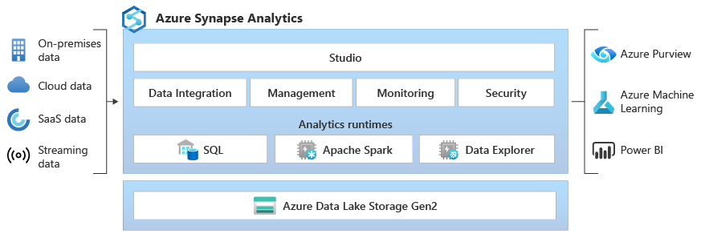

**Azure Synapse Analytics Architecture:**

Azure Synapse Analytics integrates big data and data warehousing, providing a unified analytics platform. The architecture includes various components:

**SQL Pools:**

Azure Synapse Analytics includes SQL Pools for data warehousing. These pools are used to store and process structured data, and they support massively parallel processing (MPP) for high-performance queries.

**Apache Spark Pools:**

Synapse includes Apache Spark Pools for big data processing. These pools enable processing large volumes of data using Spark-based operations.

**Data Integration:**

Azure Synapse integrates with Azure Data Factory for ETL (Extract, Transform, Load) processes. Data pipelines can be created to move and transform data from various sources to Synapse.

**On-Demand and Serverless Query:**

Synapse provides on-demand and serverless query options for ad-hoc queries and exploration. You can analyse data without the need to provision dedicated resources.

**Security and Identity:**

Azure Synapse ensures security through features like Virtual Network Service Endpoints, Managed Virtual Network, and integration with Azure Active Directory for identity and access management.

**Integration with Other Azure Services:**

Azure Synapse integrates with other Azure services like Azure Storage, Azure Databricks, and Azure Machine Learning, providing a comprehensive analytics platform.